**StarLabs 2022 - Documentation**

**Unit Testing**

***UNIT TESTING*** is a type of software testing where individual units or components of a software are tested. The purpose is to validate that each unit of the software code performs as expected. Unit Testing is done during the development (coding phase) of an application by the developers.

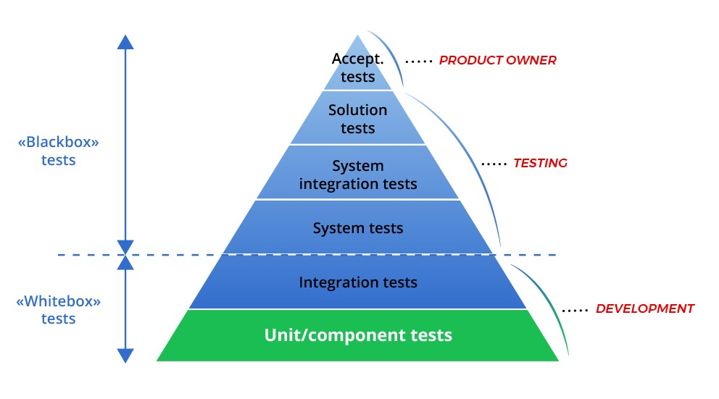

***Why Unit Testing?***

Unit Testing is important because software developers sometimes try saving time doing minimal unit testing and this is myth because inappropriate unit testing leads to high cost Defect fixing during System Testing, Integration Testing and even Beta Testing after application is built. If proper unit testing is done in early development, then it saves time and money in the end.

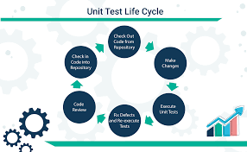

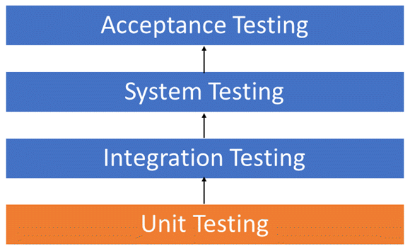

**Key reasons to perform unit testing in software engineering:**

1. Unit tests help to fix bugs early in the development cycle and save costs.
2. It helps the developers to understand the testing code base and enables them to make changes quickly
3. Good unit tests serve as project documentation
4. Unit tests help with code re-use. Migrate both your code **and** your tests to your new project. Tweak the code until the tests run again.

***What Do Unit Tests Look Like?***

A unit can be almost anything you want it to be a line of code, a method, or a class. Generally though, smaller is better. Smaller tests give you a much more granular view of how your code is performing. There is also the practical aspect that when you test very small units, your tests can be run fast; like a thousand tests in a second fast.

***Advantages of Unit Testing***

1. It reduces or prevents production bugs
2. Increases developer productivity
3. Encourages modular programming

***Disadvantages of Unit Testing***

1. It is time-consuming
2. Can’t be challenging to cover all the code
3. And won’t catch all bugs